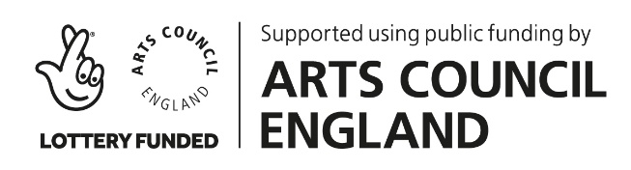

APPLICATION FOR OUTDOOR ARTS TRAINING SCHEME
If you have any problems completing this form, or if you have any questions, please contact Ruth by email on admin@prom-prom.com
Name
Date of Birth
You must be aged 18 - 25 to apply
Email Address
Phone Number
Address
Postcode
You must live, work or attend college / university in Devon to apply
Name of school / college / university where you are currently studying OR Place of work
Course / Subject
(eg: BTEC Performing Arts, BA Drama,
A-Level Theatre Studies)
You only need to tell us about Performing Arts related courses / subjects
Do you have any access needs that you would like us to be aware of?
Please tell us why you are applying for this scheme.

You might want to think about:
- What interests you about street performance / outdoor arts?
- What are you hoping to learn from the scheme?
- Do you have an example of a time you showed commitment to a project?
- What do you think your strengths are as a performer?

Please keep your answer to max two pages.

This final section is optional. You can choose to answer all, some, or none of the questions.
If you do answer any of these questions, the information will be removed from the application form before it is read by the shortlisting panel.
We use it to monitor how we are doing in our aims to work with a diverse range of people.

I identify my gender as
I identify my ethnicity as
I would describe my socio-economic or class background as
Do you consider yourself to be disabled?
This might include a sensory, mobility or learning impairment; a long-term health condition (including mental health conditions) or being neurodiverse.
If you would like to specify, please do.

Thank you for taking the time to complete this form and to apply for the Outdoor Arts Training Scheme.

Please send your completed form to admin@prom-prom.com
by 9am on Friday 28 May 2021

